

### 

##### Semester Two Examination, 2020

##### Question Paper

### ATAR ENGLISH

##### Year 12 Units 3&4

##### Time allowed for this paper

Reading time before commencing work: ten minutes

Working time for paper: three hours

##### Materials required/recommended for this paper

***To be provided by the supervisor***

This Question Paper

Standard Answer Book

***To be provided by the candidate***

Standard items: pens (blue/black preferred), pencils (including coloured), sharpener,

correction fluid/tape, eraser, ruler, highlighters

Special items: nil

##### Important note to candidates

No other items may be taken into the examination room. It is **your** responsibility to ensure that you do not have any unauthorised material. If you have any unauthorised material with you, hand it to the supervisor **before** reading any further.

##### Structure of this paper

|  |  |  |  |  |  |
| --- | --- | --- | --- | --- | --- |
| Section | Number of questions available | Number of questions to be answered | Suggested working time (minutes) | Marks available | Percentage of examination |
| Section One  Comprehending | 3 | 3 | 60 | 30 | 30 |
| Section Two  Responding | 6 | 1 | 60 | 40 | 40 |
| Section Three  Composing | 5 | 1 | 60 | 30 | 30 |
|  |  |  |  | **Total** | 100 |

##### Instructions to candidates

1. The rules for the conduct of examinations are detailed in the school handbook. Sitting this examination implies that you agree to abide by these rules.
2. Write your answers in the Standard Answer Book.
3. You must be careful to confine your answers to the specific question asked and to follow any instructions that are specified to a particular question.
4. You must not use texts from Section One to answer questions from Section Two.

Section One: Comprehending 30% (30 Marks)

In this section there are **three** texts and **three** questions. Answer **all** questions**.**

You are required to comprehend and analyse unseen written and visual texts and respond concisely in approximately 200–300 words for each question.

Suggested working time: 60 minutes.

Question 1 (10 marks)

Analyse how language features and perspectives generate controversy in **Text 1**.

**Text 1**

*An* *extract from the essay* ‘The End of Walking’ (2019) *by American author, Antonia Malchik.*

Over the past 80 years, walking simply as a way to get somewhere, let alone for pleasure, has become an alien concept to Americans. Plans to make neighbourhoods more walkable are met with fierce, indignant resistance by many residents. Much of this fight has to do with who pays for sidewalks. Once an area has been designed without walkability in mind, it’s extremely expensive to reverse infrastructure. Municipalities and suburbs alike must consider curbs, gutters, stormwater runoff, ongoing maintenance, and snow removal. I live in Montana, where homeowners are legally obliged to keep sidewalks clear of snow with shovels or snowblowers. It’s excellent exercise, but not necessarily fun, especially for the elderly or disabled. In heavy winters it’s not uncommon then, to see pedestrians give up on icy sidewalks and shift to well-cleared roads instead. Resistance to sidewalks, and to walking, often splits along generational lines. People who have come of age and grown old in a car-centric culture have trouble seeing why they should pay more to enable walkers. One suburb in Chicago fought calls by younger families for more sidewalks so bitterly, that it ended up with a walkway stopping pointlessly halfway down a block. ‘Cement companies are the only ones who benefit,’ an opponent of proposed sidewalks was quoted in the Wall Street Journal. ‘Nobody walks on King Road. Everybody drives.’ Anecdotally, one hears of communities, where proposed infrastructure to promote walking brings out grumbles that only the poor, the great unwashed, the criminal and under-classes have any use for sidewalks and pedestrian-friendly roads.

On at a deeper level, Americans’ attachment to private property and individual liberty – which are rife with a history of racial and class tensions – drive us to mistrust walking. “It’s that ‘get off my lawn, get off my sidewalk’ feeling,” says Kate Kraft, an expert in environmental health, and spokesperson for America Walks. “People get this fear that ‘undesirables’ will be walking through their neighbourhoods.” This kind of attitude seems uniquely American. When I lived in Europe, walking and public transport were more common than driving. When I moved back to Montana, I never adjusted to the assumption that a 10-minute walk required a motor vehicle. Dependence on cars and the distrust of walkers has become the hallmark of an everybody-for-themself, falsely self-sufficient American culture. Freedom to drive when and how we please is as American as apple pie and a gun holster. Freedom to walk is not.

Question 2 (10 marks)

Evaluate how **Text 2** is persuasive in its visual impact and representation of community attitudes.

**Text 2**

*Photograph of a nationwide protest rally in Queensland that featured on a news website in 2012.*



Question 3 (10 marks)

Explain how techniques promote values and ideas to position a target audience in **Text 3**.

**Text 3**

*An extract from Kurt Fearnley’s speech at the Don Award, Sports Australia Hall of Fame gala dinner, in 2018. He is the first athlete with a disability to win Australian sport's highest honour.*

I grew up with the understanding that the Don Award was as much about integrity and humility as it was about excellence in sport. I recognise tonight, that I am the first within our Paralympic movement to hold up this prestigious award, but I have no intention of self - congratulation. I have to point back behind me to the generations of proud men and women with disabilities who enabled me to become the person and athlete you see fit to receive this award. I’ve heard the stories of Paralympians who speak about losing friends, who felt shame in their experience with disability - and that is within our own community. There was too much shame and not enough hope. Our sport was born out of the hope that we can be judged by substance and not by image. That the difference that we each hold, can be celebrated and not used to segregate us. Hope, that if sport can adjust to include those with disabilities, maybe the community can follow. Our movement is more important than ever now. Because, we know the image of perfection is not real, it’s not sustainable and it’s not healthy. Our ability to share beauty and strength, to challenge perceived imperfection, cannot be matched.

I believe that sport can lead this country and I believe our Paralympic movement is a jewel within the sporting crown. I know a few people out there are saying I should just accept this award and bugger off. But sport within this country has never been about the individual… It’s been about leading. Sir Donald Bradman once said that athletes who receive recognition, also have a duty to mankind. I acknowledged earlier that I am the first Paralympian athlete to receive this award, and I am incredibly grateful to have been given this opportunity – but I guarantee I won’t be the last. We need every person in this room to embrace our community of people with disabilities; not only on the sporting field but within administration, executive and governance roles. Let’s lead the way. We won’t regret it. There’s enough strength and substance in our community to build a country on.

**End of Section One**

**This page has been left blank intentionally**

**Section Two: Responding 40% (40 Marks)**

In this section there are **six** questions. Answer **one** question.

Your response should demonstrate your analytical and critical thinking skills with reference to  
any text or text type you have studied.

Suggested working time: 60 minutes.

Question 4 (40 marks)

Discuss the representation of voice and perspectives in a text that feels relevant for our time.

Question 5 (40 marks)

Consider how genre conventions and themes frame the way you interpret an event in at least one text.

Question 6 (40 marks)

Compare how two texts contextualise attitudes and use language choices to position response to prejudice.

Question 7 (40 marks)

Discuss how structural and stylistic elements represent a powerful personality and create impact in a text.

Question 8 (40 marks)

Analyse how a multimodal text represents diversity and persuades its audience to “step into the shoes” of others.

Question 9 (40 marks)

Contrast the way two texts shape a sense of purpose and evaluate ideas and values worth sharing.

**End of Section Two**

**This page has been left blank intentionally**

**Section Three: Composing 30% (30 marks)**

In this section there are **five** questions. Answer **one** question.

You are required to demonstrate writing skills by choosing a form of writing appropriate to a specific audience, context and purpose.

Suggested working time: 60 minutes.

Question 10 (30 marks)

Tough questions and big ideas.  
  
Write a text that persuades an audience that some voices are worth listening to.

Question 11 (30 marks)

‘We are always joined in our sufferings, often by somebody we can’t see through the darkness.’  
  
Compose a text that interprets the concept of ’solidarity’ in a year of upheaval.

Question 12 (30 marks)

In a form of your choice create a text that engages with the mood and ideas in this image.

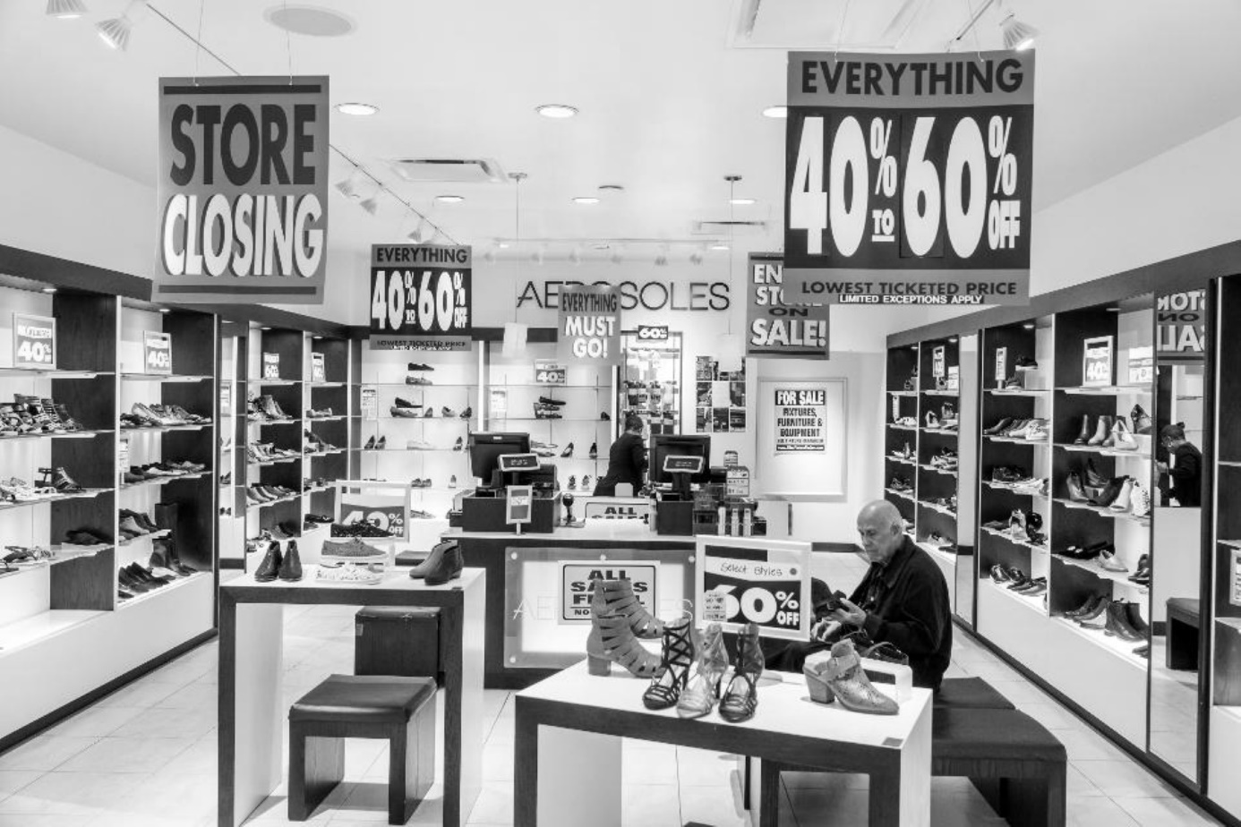

Question 13 (30 marks)

Craft an entertaining, narrative piece of writing that starts with the words:  
  
The day began with nothing to look forward to…

Question 14 (30 marks)

Inspired by this representation, write an interpretive text to convey your views of ‘kids who need help’.

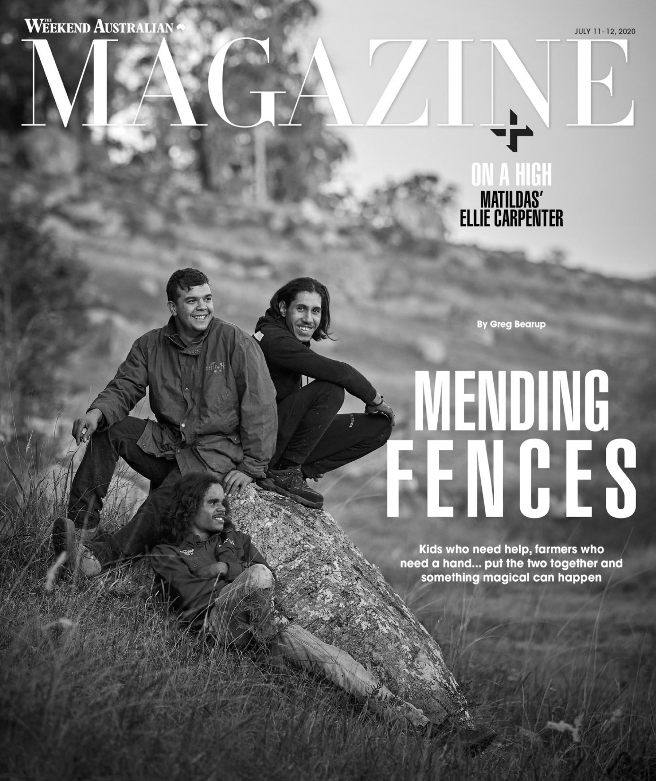

**ACKNOWLEDGEMENTS**

**Text 1** Malchick, A. Essay extract: ‘*The End of Walking*’. Aeon magazine (2019).

**Text 2** Photograph, The Courier Mail. ‘*Ban animal export rally in Queensland*.’ (2012).

**Text 3** Fearnley, K. Speech extract: *The Don Award, Sports Australia Hall of Fame gala dinner* (2018).

**Question 11** Quote sourced from the article ‘*The Argument of “Afropessimism*”’ The New Yorker (2020).

**Question 12** Photograph: Universal Images Group (2020). Opera News article: ‘*Retailers, if you think 2020 is bad, wait because it is going to get worse*.’

**Question 14** Copy of *The Weekend Australian* magazine cover July 2020.

© 2020 WA Exam Papers. Leeming Senior High School has a non-exclusive licence to copy and communicate this document for non-commercial, educational use within the school. No other copying, communication or use is permitted without the express written permission of WA Exam Papers. Some material in the exam has been copied (and communicated to you) in accordance with the Exam Copying Exception in Section 200(1A) of the Copyright Act. Any further reproduction or communication of this material by you may be the subject of copyright protection under the Act. Do not remove this notice. SN056-759-1.